Assignment – 4.3
Name – ERUKULLA MAHANTH ARYA
Hall-ticket – 2303A54028
AI Assistant Coding

# Task 1: Zero-Shot Prompting – Leap Year Check
Prompt : Generate a Python function that takes a year as input, determines whether it is a leap year using correct logic, returns the result, and include sample input and output
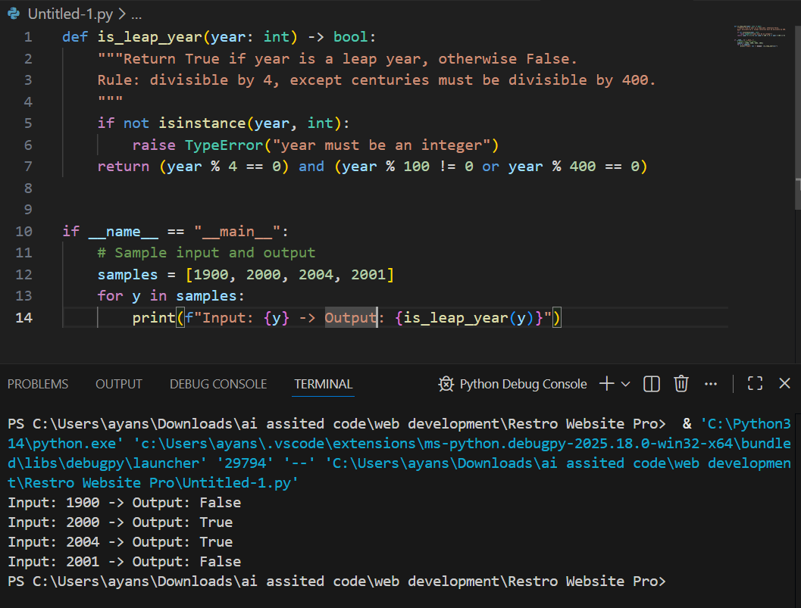
# Task 2: one-Shot Prompting – Centimeters to Inches Conversion
Prompt: Generate a Python function that converts centimeters to inches using the correct formula. Example: Input: 10 cm → Output: 3.94 inches. Include sample test cases and outputs.
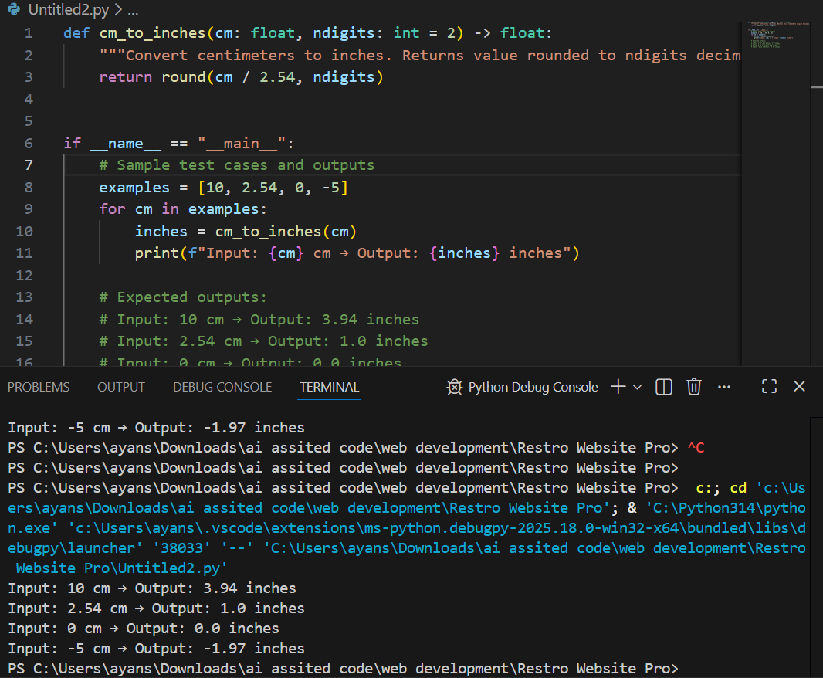

#Task 3: Few-Shot Prompting – Name Formatting
Prompt: Generate a Python function that takes a full name as input and formats it as ‘Last, First’. Examples: ‘John Smith’ → ‘Smith, John’; ‘Anita Rao’ → ‘Rao, Anita’. Include sample inputs and outputs

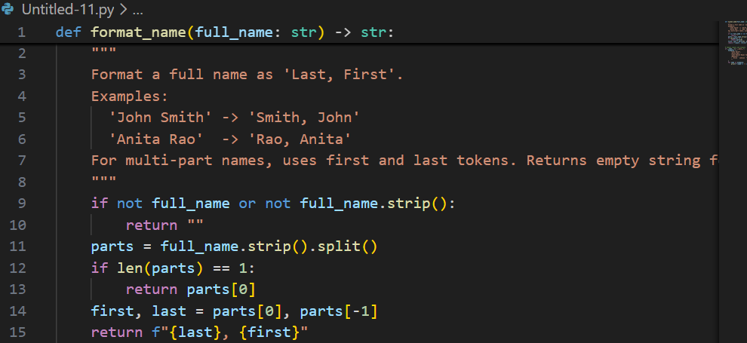
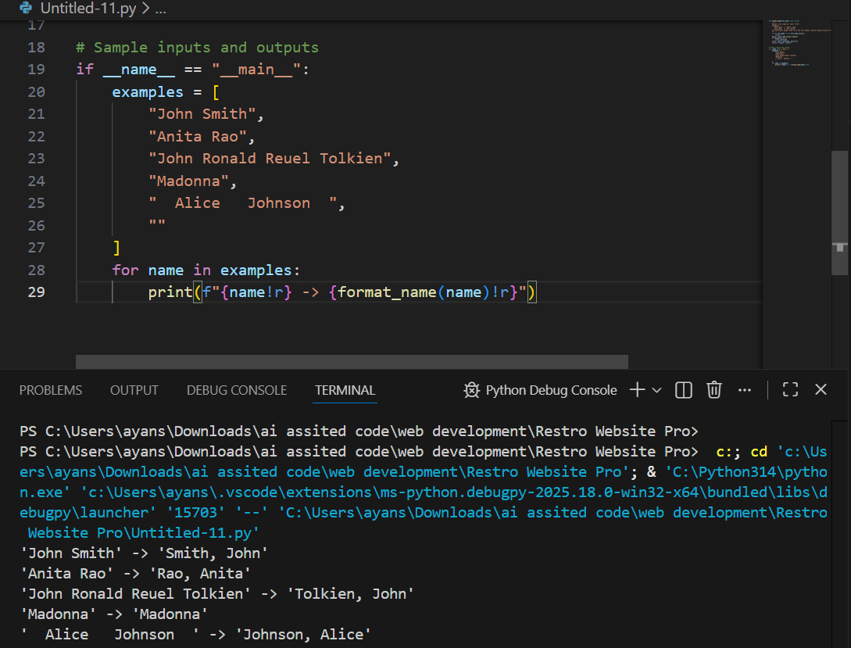

#Task 4: Comparative Analysis – Zero-Shot vs Few-Shot
Prompt: Using zero-shot prompting, generate a Python function that counts vowels in a string. Then, using few-shot prompting, generate the same function. Compare both implementations based on accuracy, readability, and logical clarity, and conclude which prompting method is more effective
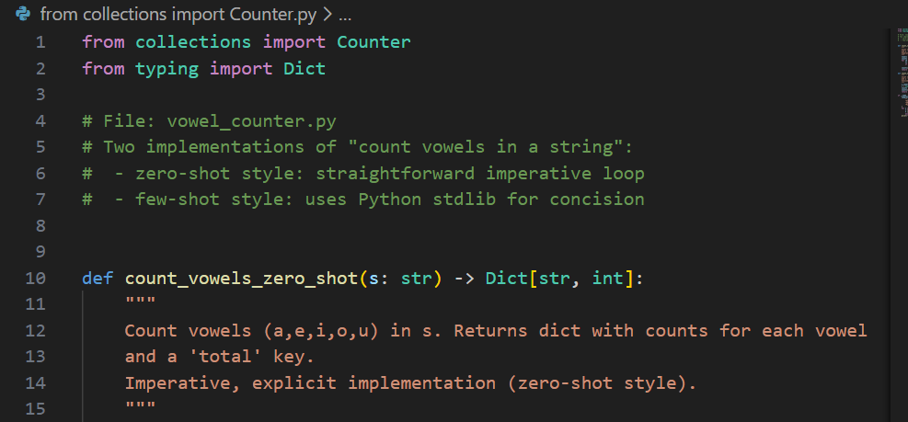
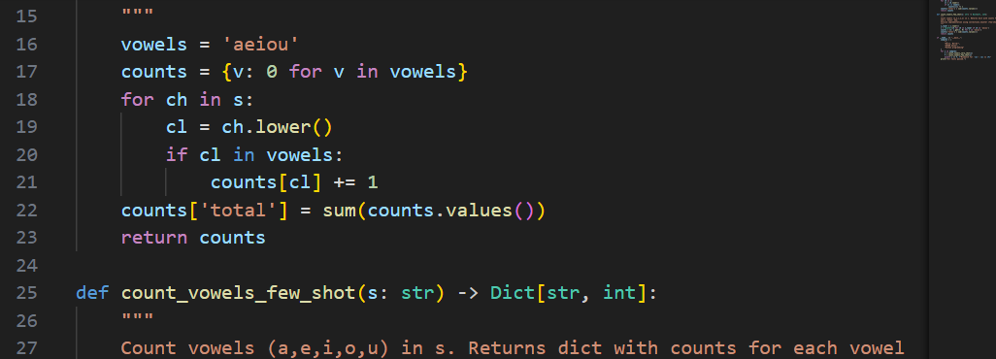
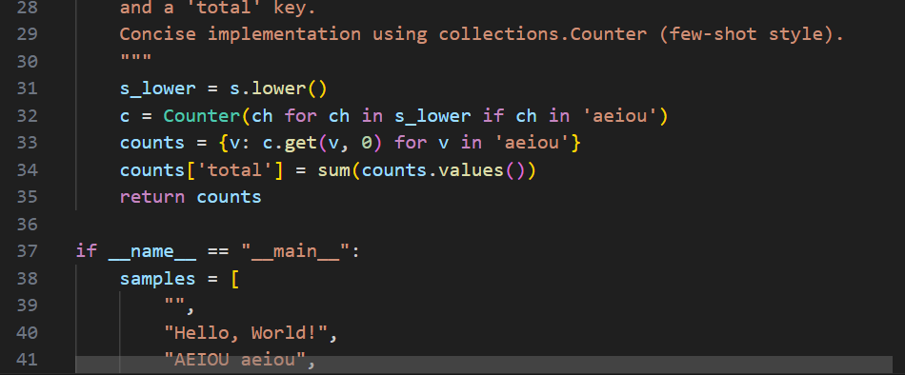
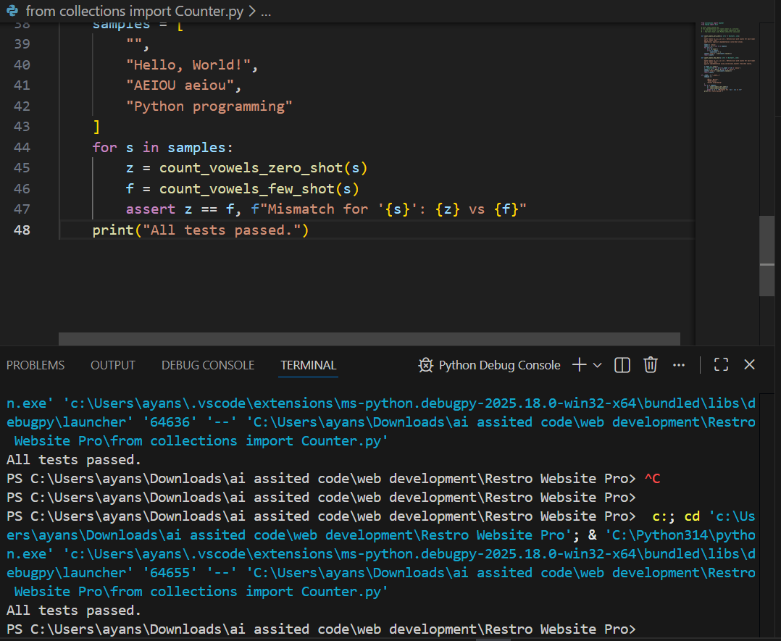

#Task 5: Few-Shot Prompting – File Handling
Prompt: Generate a Python function that reads a .txt file and returns the number of lines. Example: Input file with 3 lines → Output: 3. Include sample input/output and briefly explain the logic.
